

# MESH NETWORK

**COMMUNICATION**

**Supervisor: Sandra French**

## TEAM MEMBERS

Swathi Thekkuveettil Reshma Kallungal Paul Manisha Arora

## INTRODUCTION

In our project ,the main parts are the STM32f401 module and the NRF24L01 module. After going through the reference manual(chapter 8) we get to know that NRF24L01 uses a standard SPI with a maximum data rate of 10mbps.so the first step was to write the SPI commands to our code and we also tried to initialize the modes that is shock burst mode, Enhanced Shock burst, and enhanced shock burst with bi directional data. These are the 2 steps we tried to implement in this code we wrote the code for these but as per Mikes instruction to add on a further ado we have to use a single mode as default so we planned to make Enhanced shockburst with bidirectional data as default.

## PROJECT OVERVIEW AND WORKING

SPI Operation Mode

In the reference manual or data sheets (page no:50 chapter 8). the serial commands are used in this way the most significant bit must be sent first. if the command is longer than one word least significant bit must be send first. Shift select must be lowered before the start of the communication a nd should be pulled up only when every word is shifted.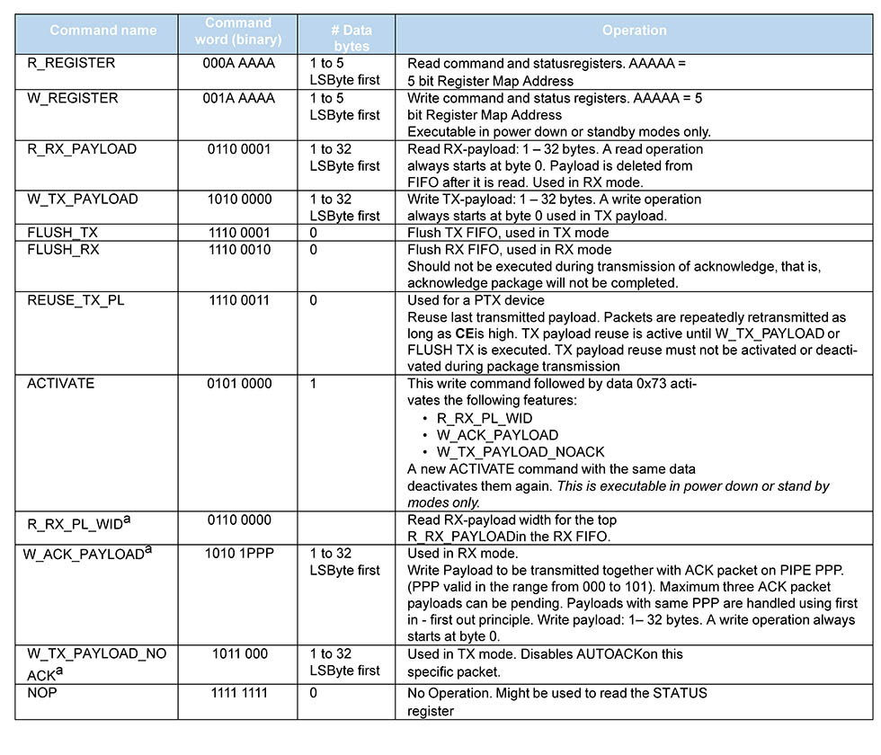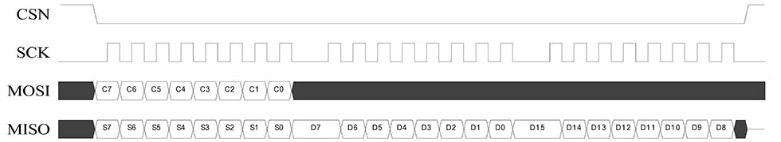

**INITIAL SOFTWARE CREATION PLANNING**



PTX – Transmitter

PRX -Receiver

**FLOW CHART**



**SOURCE CODE FLOWCHART**

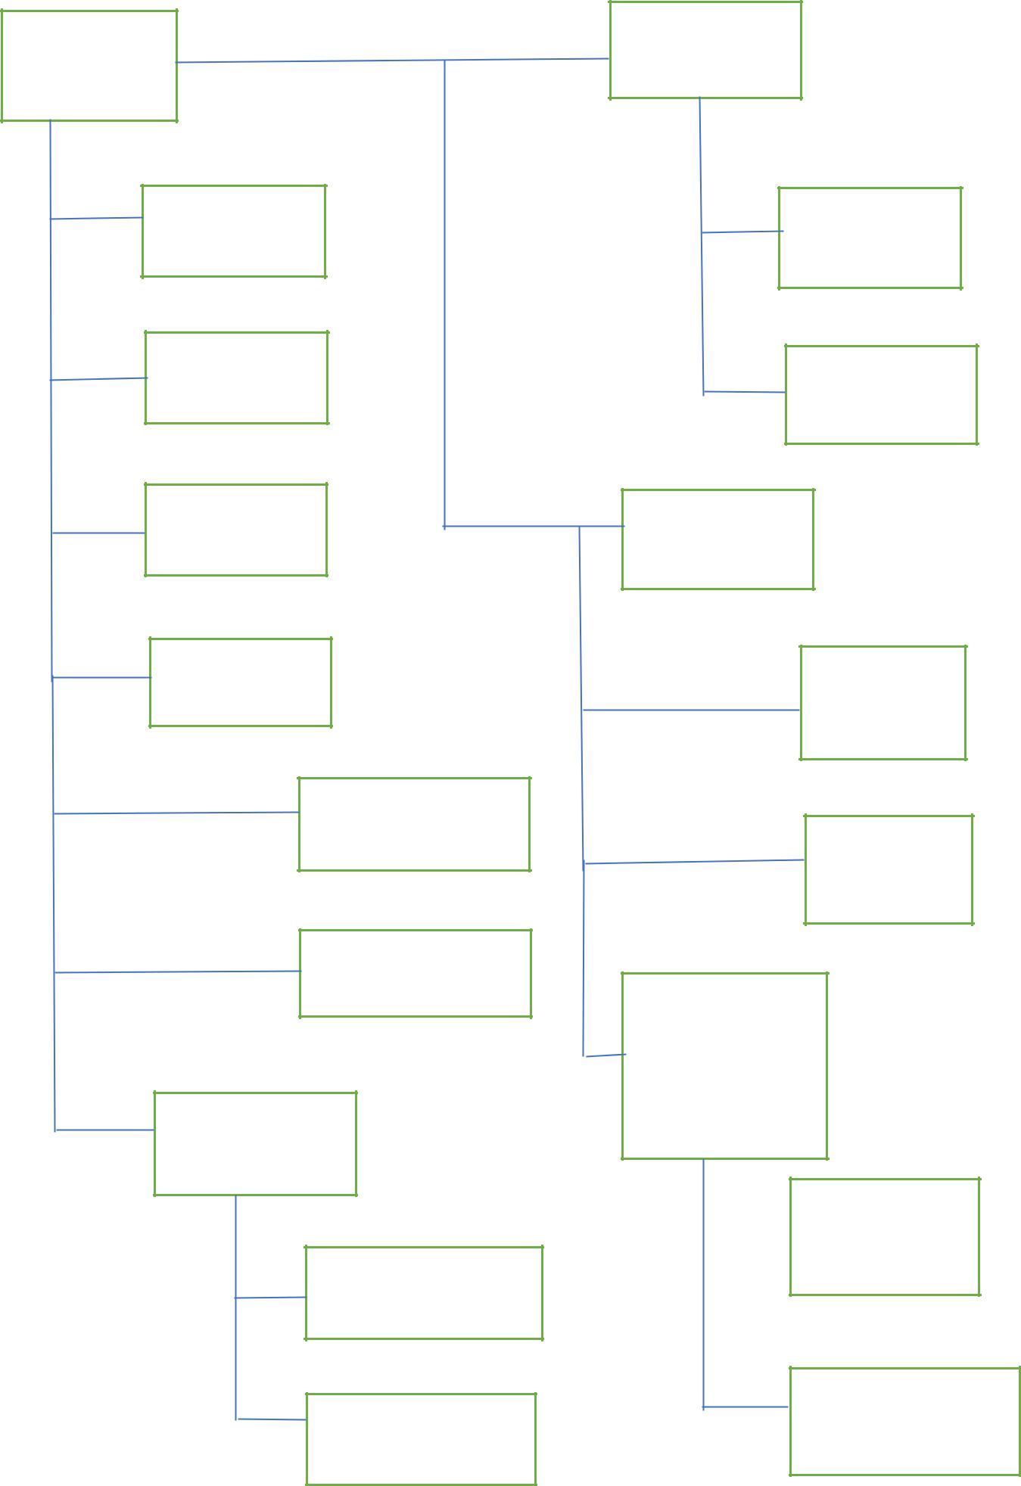

Root ShockBurst(SB)

main.h/.c

Radio-sb.h/.c

system.h/.c

application-sb.h/.c

radio.h/.c

enhanced

Schockburst

nRF24L01

radio-esb.h/.c

target_includes.h

application_esb

.h/.c

mcu.c

Enhanced

Schockburst with

Bi-directional

data

nRF24L01

radio-pl.h/.c

Target-includes.h

Application-pl.h/.c

Target_includes.h

**The code**

#include <stdint.h>

#include <stdbool.h>

#include <stdio.h>

#include <ctype.h>

#include "common.h"

/** LED should be on */

#define ON 1

/** LED should be off */

#define OFF 0

/** Function should loop for 0 seconds */

#define SEK_0 0

/** Function should loop for aprox 1 seconds */

#define SEK_1 10

/** Function should loop for aprox 2 seconds */

#define SEK_2 20

/** Function should loop for aprox 3 seconds */

#define SEK_3 30

#define TIMER1_OVERFLOW() (TF1 == 1) /**< Checks for overflow on timer1 */

#define MAX_RUNTIME 65 /** The maximum runtime in ms that a timer might run. Calculated by

* taking the maximum number your timer might take and divide that by

* @b CYCLES_PR_MS. On the nRF24L01 evaluation kit this is 0xFFFF / 1000 =

* 65 (aprox).

*/

#define MAX_TIME (0 - MAX_RUNTIME * CYCLES_PR_MS) /** This constant defines the value the timer should be set to for running for

* the maximum time.

*/

/** Start timer1. */

#define T1_START() do{ TR1 = 1; \

ET1 = 0; \

TF1 = 0; \

EA = 1; \

}while(0)

/** Stop timer1. */

#define T1_STOP() do{ TR1 = 0; \

ET1 = 0; \

}while(0)

/** Initialise Timer 1 in mode 1 (16-bit timer) */

#define T1_MODE1() (TMOD |= 0x10)

/** Sets the low bit of timer 1 */

#define T1_SET_LB(x) (TL1 = x)

/** Sets the high bit of timer 1 */

#define T1_SET_HB(x) (TH1 = x)

#define RADIO_ACTIVITY() (IE0 == 1) /**< The register on the radio indicating

* activity on the radio */

/** How to reset the activity register */

#define RESET_RADIO_ACTIVITY() (IE0 = 0)

/** Tx side System setup */

SPI_HandleTypeDef hspi1;

UART_HandleTypeDef huart2;

/** Tx side System setup end */

/* Private function prototypes for Radio -----------------------------------------------*/

void SystemClock_Config(void);

static void MX_GPIO_Init(void);

static void MX_SPI1_Init(void);

static void MX_USART2_UART_Init(void);

/* Private function prototypes for Radio ends -----------------------------------------------*/

int pinState1=1,pinState2=1,pinState3=1;

static uint8_t timer_rounds;

static radio_status_t status;

static xdata uint8_t pload_sb[RF_PAYLOAD_LENGTH];

typedef enum {

DEVICE_IDLE = 0, /**< The device is idle */

DEVICE_PRX_IDLE, /**< The device will operate in @b PRX mode */

DEVICE_PTX_IDLE, /**< The device will operate in @b PTX mode */

DEVICE_PRX_SB, /**< The device will operate in @b PRX mode with ShockBurst functionailty */

DEVICE_PRX_ESB, /**< The device will operate in @b PRX mode with Enhanced ShockBurst functionailty */

DEVICE_PRX_PL, /**< The device will operate in @b PRX mode with Enhanced ShockBurst functionailty with Bidirectional data */

DEVICE_PTX_SB, /**< The device will operate in @b PTX mode with ShockBurst functionailty */

DEVICE_PTX_ESB, /**< The device will operate in @b PTX mode with Enhanced ShockBurst functionailty */

DEVICE_PTX_PL, /**< The device will operate in @b PTX mode with Enhanced ShockBurst functionailty with Bidirectional data */

NO_CHANGE /**< No state change */

} state_t;

static const state_t state_machine[][3] =

// B1 B2 B3 CURRENT STATE

{ {DEVICE_PTX_IDLE, DEVICE_PRX_IDLE, NO_CHANGE}, /**< DEVICE_IDLE */

{DEVICE_PRX_SB, DEVICE_PRX_ESB, DEVICE_PRX_PL}, /**< DEVICE_PRX_IDLE */

{DEVICE_PTX_SB, DEVICE_PTX_ESB, DEVICE_PTX_PL}, /**< DEVICE_PTX_IDLE */

{NO_CHANGE, NO_CHANGE, NO_CHANGE}, /**< DEVICE_PRX_SB */

{NO_CHANGE, NO_CHANGE, NO_CHANGE}, /**< DEVICE_PRX_ESB */

{NO_CHANGE, NO_CHANGE, NO_CHANGE}, /**< DEVICE_PRX_PL */

{NO_CHANGE, NO_CHANGE, NO_CHANGE}, /**< DEVICE_PTX_SB */

{NO_CHANGE, NO_CHANGE, NO_CHANGE}, /**< DEVICE_PTX_ESB */

{NO_CHANGE, NO_CHANGE, NO_CHANGE} /**< DEVICE_PTX_PL */

};

static const uint8_t show_state[][5] =

//LED1, LED2, LED3, ALL off after?, Time,

{{ON , ON , ON , ON, SEK_0}, /**< DEVICE_IDLE */

{OFF, OFF, ON , ON, SEK_0}, /**< DEVICE_PRX_IDLE */

{OFF, OFF, OFF, ON, SEK_0}, /**< DEVICE_PTX_IDLE */

{ON , OFF, ON , OFF, SEK_3}, /**< DEVICE_PRX_SB */

{OFF, ON , ON , OFF, SEK_3}, /**< DEVICE_PRX_ESB */

{ON , ON , ON , OFF, SEK_3}, /**< DEVICE_PRX_PL */

{ON , OFF, OFF, OFF, SEK_3}, /**< DEVICE_PTX_SB */

{OFF, ON , OFF, OFF, SEK_3}, /**< DEVICE_PTX_ESB */

{ON , ON , OFF, OFF, SEK_3}, /**< DEVICE_PTX_PL */

};

/** The address of the radio. Parameter to the radio init */

static code const uint8_t address[HAL_NRF_AW_5BYTES] = {0x22,0x33,0x44,0x55,0x01};

static state_t get_next_state(state_t current_state);

/** Function that runs in a loop until all buttons are released.

*/

static void wait_for_button_release(void);

/** Shows the state the state_machine is in.

*/

static void show_status(state_t operation);

/** the following function is for hardware device setup.

*/

void system_init (void);

/** Blinks the LED's to check the start device

*/

void device_boot_msg(void);

/** Blinks the LED's to check the start device

*/

void LED_ALL_OFF(void);

/** the following is for checking the buttons are pressed or not

*/

int B1_PRESSED(void);

/** the following is for checking the buttons are pressed or not

*/

int B2_PRESSED(void);

/** the following is for checking the buttons are pressed or not

*/

int B3_PRESSED(void);

/** the following is for turning on the corresponding LED

*/

void LED1_ON(void);

/** the following is for turning on the corresponding LED

*/

void LED2_ON(void);

/** the following is for turning on the corresponding LED

*/

void LED3_ON(void);

/** the following is for timing controll units

*/

void start_timer (uint16_t time);

/** the following is for timing controll units

*/

void wait_for_timer (void);

/** the following is for setting up the radio in SB mode

*/

void radio_sb_init (const uint8_t *address, hal_nrf_operation_mode_t operational_mode);

/** the following is for getting the radio status

*/

void radio_set_status (radio_status_t new_status);

/** the following is for receiving mode

*/

void device_prx_mode_sb(void);

/** the following is for radio setup

*/

void radio_irq(void);

/** the following is for getting the status of the radio

*/

radio_status_t radio_get_status (void);

/** the following is for getting timing value

*/

bool timer_done (void);

/** the following is for getting timing value

*/

uint8_t radio_get_pload_byte (uint8_t byte_index);

/** the following is for initialising the radio in esb mode

*/

void radio_esb_init (const uint8_t *address, hal_nrf_operation_mode_t operational_mode);

/** the following is for initialising the radio in pl mode

*/

void radio_pl_init (const uint8_t *address, hal_nrf_operation_mode_t operational_mode);

/** the following is for transmitting in SB mode

*/

void device_ptx_mode_sb(void);

/** this is to send a data in air

*/

void radio_send_packet(uint8_t *packet, uint8_t length);

/** the following is for transmitting in ESB mode

*/

void device_ptx_mode_esb(void);

/** the following is for receivingin ESB mode

*/

void device_prx_mode_esb(void);

/** the following is for transmitting in PL mode

*/

void device_ptx_mode_pl(void);

/** the following is for receivingin PL mode

*/

void device_prx_mode_pl(void);

void radio_send_packet(uint8_t *packet, uint8_t length)

{

hal_nrf_write_tx_pload(packet, length); // load message into radio

//CE_PULSE(); // send packet // i dont know where to find this section yet

radio_set_status (RF_BUSY); // trans. in progress; RF_BUSY

}

void radio_pl_init (const uint8_t *address, hal_nrf_operation_mode_t operational_mode)

{

hal_nrf_close_pipe(HAL_NRF_ALL); // First close all radio pipes

// Pipe 0 and 1 open by default

hal_nrf_open_pipe(HAL_NRF_PIPE0, true); // Then open pipe0, w/autoack

hal_nrf_set_crc_mode(HAL_NRF_CRC_16BIT); // Operates in 16bits CRC mode

hal_nrf_set_auto_retr(RF_RETRANSMITS, RF_RETRANS_DELAY);

// Enables auto retransmit.

// 3 retrans with 250ms delay

hal_nrf_set_address_width(HAL_NRF_AW_5BYTES); // 5 bytes address width

hal_nrf_set_address(HAL_NRF_TX, address); // Set device's addresses

hal_nrf_set_address(HAL_NRF_PIPE0, address); // Sets recieving address on

// pipe0

/*****************************************************************************

* Changed from esb/radio_esb.c *

* Enables: *

* - ACK payload *

* - Dynamic payload width *

* - Dynamic ACK *

*****************************************************************************/

hal_nrf_enable_ack_pl(); // Try to enable ack payload

// When the features are locked, the FEATURE and DYNPD are read out 0x00

// even after we have tried to enable ack payload. This mean that we need to

// activate the features.

if(hal_nrf_read_reg(FEATURE) == 0x00 && (hal_nrf_read_reg(DYNPD) == 0x00))

{

hal_nrf_lock_unlock (); // Activate features

hal_nrf_enable_ack_pl(); // Enables payload in ack

}

hal_nrf_enable_dynamic_pl(); // Enables dynamic payload

hal_nrf_setup_dyn_pl(ALL_PIPES); // Sets up dynamic payload on

// all data pipes.

/*****************************************************************************

* End changes from esb/radio_esb.c *

*****************************************************************************/

if(operational_mode == HAL_NRF_PTX) // Mode depentant settings

{

hal_nrf_set_operation_mode(HAL_NRF_PTX); // Enter TX mode

}

else

{

hal_nrf_set_operation_mode(HAL_NRF_PRX); // Enter RX mode

hal_nrf_set_rx_pload_width((uint8_t)HAL_NRF_PIPE0, RF_PAYLOAD_LENGTH);

// Pipe0 expect

// PAYLOAD_LENGTH byte payload

// PAYLOAD_LENGTH in radio.h

}

hal_nrf_set_rf_channel(RF_CHANNEL); // Operating on static channel

// Defined in radio.h.

// Frequenzy =

// 2400 + RF_CHANNEL

hal_nrf_set_power_mode(HAL_NRF_PWR_UP); // Power up device

start_timer(RF_POWER_UP_DELAY); // Wait for the radio to

wait_for_timer(); // power up

radio_set_status (RF_IDLE); // Radio now ready

}

void radio_esb_init (const uint8_t *address, hal_nrf_operation_mode_t operational_mode)

{

hal_nrf_close_pipe(HAL_NRF_ALL); // First close all radio pipes

// Pipe 0 and 1 open by default

hal_nrf_open_pipe(HAL_NRF_PIPE0, true); // Then open pipe0, w/autoack

// Changed from sb/radio_sb.c

hal_nrf_set_crc_mode(HAL_NRF_CRC_16BIT); // Operates in 16bits CRC mode

hal_nrf_set_auto_retr(RF_RETRANSMITS, RF_RETRANS_DELAY);

// Enables auto retransmit.

// 3 retrans with 250ms delay

// Changed from sb/radio_sb.c

hal_nrf_set_address_width(HAL_NRF_AW_5BYTES); // 5 bytes address width

hal_nrf_set_address(HAL_NRF_TX, address); // Set device's addresses

hal_nrf_set_address(HAL_NRF_PIPE0, address); // Sets recieving address on

// pipe0

if(operational_mode == HAL_NRF_PTX) // Mode depentant settings

{

hal_nrf_set_operation_mode(HAL_NRF_PTX); // Enter TX mode

}

else

{

hal_nrf_set_operation_mode(HAL_NRF_PRX); // Enter RX mode

hal_nrf_set_rx_pload_width((uint8_t)HAL_NRF_PIPE0, RF_PAYLOAD_LENGTH);

// Pipe0 expect

// PAYLOAD_LENGTH byte payload

// PAYLOAD_LENGTH in radio.h

}

hal_nrf_set_rf_channel(RF_CHANNEL); // Operating on static channel

// Defined in radio.h.

// Frequenzy =

// 2400 + RF_CHANNEL

hal_nrf_set_power_mode(HAL_NRF_PWR_UP); // Power up device

start_timer(RF_POWER_UP_DELAY); // Wait for the radio to

wait_for_timer(); // power up

radio_set_status (RF_IDLE); // Radio now ready

}

void radio_sb_init (const uint8_t *address, hal_nrf_operation_mode_t operational_mode)

{

hal_nrf_close_pipe(HAL_NRF_ALL); // First close all radio pipes

// Pipe 0 and 1 open by default

hal_nrf_open_pipe(HAL_NRF_PIPE0, false); // Open pipe0, without/autoack

hal_nrf_set_crc_mode(HAL_NRF_CRC_16BIT); // Operates in 16bits CRC mode

hal_nrf_set_auto_retr(0, RF_RETRANS_DELAY); // Disables auto retransmit

hal_nrf_set_address_width(HAL_NRF_AW_5BYTES); // 5 bytes address width

hal_nrf_set_address(HAL_NRF_TX, address); // Set device's addresses

hal_nrf_set_address(HAL_NRF_PIPE0, address); // Sets recieving address on

// pipe0

if(operational_mode == HAL_NRF_PTX) // Mode depentant settings

{

hal_nrf_set_operation_mode(HAL_NRF_PTX); // Enter TX mode

}

else

{

hal_nrf_set_operation_mode(HAL_NRF_PRX); // Enter RX mode

hal_nrf_set_rx_pload_width((uint8_t)HAL_NRF_PIPE0, RF_PAYLOAD_LENGTH);

// Pipe0 expect

// PAYLOAD_LENGTH byte payload

// PAYLOAD_LENGTH in radio.h

}

hal_nrf_set_rf_channel(RF_CHANNEL); // Operating on static channel

// Defined in radio.h.

// Frequenzy =

// 2400 + RF_CHANNEL

hal_nrf_set_power_mode(HAL_NRF_PWR_UP); // Power up device

//hal_nrf_set_datarate(HAL_NRF_1MBPS); // Uncomment this line for

// compatibility with nRF2401

// and nRF24E1

start_timer(RF_POWER_UP_DELAY); // Wait for the radio to

wait_for_timer(); // power up

radio_set_status (RF_IDLE); // Radio now ready

}

void device_prx_mode_pl(void)

{

while(true)

{

// Setup and put the ACK payload on the FIFO

pload_pl[0] = 0;

if(B1_PRESSED())

{

pload_pl[0] = 1;

}

hal_nrf_write_ack_pload (0, pload_pl, RF_PAYLOAD_LENGTH);

start_timer(110);

// Run until either 110ms has lapsed

// OR there is data on the radio

do

{

radio_irq ();

} while ((radio_get_status () == RF_IDLE) && !timer_done());

// Blink LED2 if ACK payload was sent, LED3 if not

if ((radio_get_status ()) == RF_TX_DS

|| (radio_get_status ()) == RF_TX_AP)

{

LED2_BLINK();

}

else

{

LED3_BLINK();

}

if ((radio_get_status ()) == RF_RX_DR

|| (radio_get_status ()) == RF_TX_AP)

{

// Get the payload from the PTX and set LED1 accordingly

if (radio_get_pload_byte (0) == 1)

{

LED1_ON();

}

else

{

LED1_OFF();

}

}

else

{

LED1_OFF();

}

// Set radio status to idle

radio_set_status (RF_IDLE);

}

EX0 = 1;

}

void device_ptx_mode_pl(void)

{

while(true)

{

// Wait til the packet is sent

do {

radio_irq ();

} while((radio_get_status ()) == RF_BUSY);

// Blink LED2 if ACK is recieved, LED3 if not

if (((radio_get_status ()) == RF_TX_DS)

|| ((radio_get_status ()) == RF_TX_AP))

{

LED2_BLINK();

}

else

{

LED3_BLINK();

}

// If ACK payload was recieved, get the payload

if (radio_get_status () == RF_TX_AP)

{

// Get the payload from the PRX and set LED1 accordingly

if (radio_get_pload_byte (0) == 1)

{

LED1_ON();

}

else

{

LED1_OFF();

}

}

// Sleep 100ms

HAL_Delay(100);

// Set up the payload according to the input button 1

pload_pl[0] = 0;

if(B1_PRESSED())

{

pload_pl[0] = 1;

}

//Send the packet

radio_send_packet(pload_pl, RF_PAYLOAD_LENGTH);

}

}

void device_prx_mode_esb(void)

{

while(true)

{

start_timer(110);

// Run until either 110ms has lapsed

// OR there is data on the radio

do

{

radio_irq ();

} while ((radio_get_status () == RF_IDLE) && !timer_done());

if ((radio_get_status ()) == RF_RX_DR)

{

// Get the payload from the PTX and set LED1

if (radio_get_pload_byte (0) == 1)

{

LED1_ON();

}

else

{

LED1_OFF();

}

}

else

{

LED1_OFF();

}

// Set radio status to idle

radio_set_status (RF_IDLE);

}

}

void device_ptx_mode_esb(void)

{

while(true)

{

// Wait til the packet is sent

do {

radio_irq ();

} while((radio_get_status ()) == RF_BUSY);

// Blink LED2 if ACK is recieved, LED3 if not

if (((radio_get_status ()) == RF_TX_DS))

{

LED2_BLINK();

}

else

{

LED3_BLINK();

}

// Sleep 100ms

start_timer(100);

wait_for_timer();

// Set up the payload according to the input button 1

pload_esb[0] = 0;

if(B1_PRESSED())

{

pload_esb[0] = 1;

}

//Send the packet

radio_send_packet(pload_esb, RF_PAYLOAD_LENGTH);

}

}

void device_ptx_mode_sb(void)

{

while(true)

{

// Wait til the packet is sent

do {

radio_irq ();

} while((radio_get_status ()) == RF_BUSY);

// Sleep 100ms

start_timer(100);

wait_for_timer();

// Set up the payload according to the input button 1

pload_sb[0] = 0;

if(B1_PRESSED())

{

pload_sb[0] = 1;

}

//Send the packet

radio_send_packet(pload_sb, RF_PAYLOAD_LENGTH);

}

}

void device_prx_mode_sb(void)

{

while(true)

{

start_timer(110);

// Run until either 110ms has lapsed

// OR there is data on the radio

do

{

radio_irq ();

} while ((radio_get_status() == RF_IDLE) && !timer_done());

if ((radio_get_status ()) == RF_RX_DR)

{

// Get the payload from the PTX and set LED1 accordingly

if (radio_get_pload_byte(0) == 1)

{

LED1_ON();

}

else

{

LED1_OFF();

}

}

else

{

LED1_OFF();

}

// Set radio status to idle

radio_set_status(RF_IDLE);

}

}

uint8_t radio_get_pload_byte (uint8_t byte_index)

{

return pload[byte_index];

}

bool timer_done (void)

{

bool retval = false;

if (TIMER1_OVERFLOW())

{

timer_rounds--;

if (timer_rounds > 0)

{

run_timer (MAX_TIME);

}

else

{

retval = true;

T1_STOP();

}

}

return retval;

}

radio_status_t radio_get_status (void)

{

return status;

}

void radio_irq(void)

{

if (RADIO_ACTIVITY()) // Check if an interupt is

{ // triggered

switch(hal_nrf_get_clear_irq_flags ())

{

case (1<<HAL_NRF_MAX_RT): // Max retries reached

hal_nrf_flush_tx(); // flush tx fifo, avoid fifo jam

radio_set_status (RF_MAX_RT);

break;

case (1<<HAL_NRF_TX_DS): // Packet sent

radio_set_status (RF_TX_DS);

break;

case (1<<HAL_NRF_RX_DR): // Packet received

while (!hal_nrf_rx_fifo_empty ())

{

hal_nrf_read_rx_pload(pload);

}

radio_set_status (RF_RX_DR);

break;

case ((1<<HAL_NRF_RX_DR)|(1<<HAL_NRF_TX_DS)): // Ack payload recieved

while (!hal_nrf_rx_fifo_empty ())

{

hal_nrf_read_rx_pload(pload);

}

radio_set_status (RF_TX_AP);

break;

default:

break;

}

RESET_RADIO_ACTIVITY();

}

}

void radio_set_status (radio_status_t new_status)

{

status = new_status;

}

static void run_timer (uint16_t time)

{

if (time != 0)

{

T1_MODE1(); // Setting up mode 1 on timer 1 (16-bit timer)

T1_SET_LB((uint8_t)time);

T1_SET_HB((uint8_t)(time >> 8));

T1_START();

}

}

void wait_for_timer (void)

{

while (timer_rounds > 0)

{

while (!TIMER1_OVERFLOW())

;

timer_rounds--;

if (timer_rounds > 0)

{

run_timer (MAX_TIME);

}

}

T1_STOP();

}

void start_timer (uint16_t time)

{

uint16_t setuptime;

uint16_t firstruntime;

firstruntime = (uint16_t)(time % MAX_RUNTIME);

setuptime = 0 - (firstruntime * CYCLES_PR_MS);

time -= firstruntime;

timer_rounds = (uint8_t)(time / MAX_RUNTIME) + 1;

if (setuptime == 0)

{

setuptime = MAX_TIME;

timer_rounds--;

}

run_timer (setuptime);

}

void LED1_ON(void)

{

HAL_GPIO_WritePin(GPIOA,GPIO_PIN_0,1);

}

void LED2_ON(void)

{

HAL_GPIO_WritePin(GPIOA,GPIO_PIN_1,1);

}

void LED3_ON(void)

{

HAL_GPIO_WritePin(GPIOA,GPIO_PIN_2,1);

}

int B1_PRESSED(void)

{

pinState1 = HAL_GPIO_ReadPin(GPIOA, GPIO_PIN_3);

if(pinState1==0)

{

return 1;

}

else

{

return 0;

}

}

int B2_PRESSED(void)

{

pinState2 = HAL_GPIO_ReadPin(GPIOA, GPIO_PIN_4);

if(pinState2==0)

{

return 1;

}

else

{

return 0;

}

}

int B3_PRESSED(void)

{

pinState3 = HAL_GPIO_ReadPin(GPIOA, GPIO_PIN_5);

if(pinState3==0)

{

return 1;

}

else

{

return 0;

}

}

void LED_ALL_OFF(void)

{

HAL_GPIO_WritePin(GPIOA,GPIO_PIN_0,0);

HAL_GPIO_WritePin(GPIOA,GPIO_PIN_1,0);

HAL_GPIO_WritePin(GPIOA,GPIO_PIN_2,0);

}

void device_boot_msg(void)

{

HAL_GPIO_WritePin(GPIOA,GPIO_PIN_0,1);

HAL_Delay(500);

HAL_GPIO_WritePin(GPIOA,GPIO_PIN_0,0);

HAL_GPIO_WritePin(GPIOA,GPIO_PIN_1,1);

HAL_Delay(500);

HAL_GPIO_WritePin(GPIOA,GPIO_PIN_1,0);

HAL_GPIO_WritePin(GPIOA,GPIO_PIN_2,1);

HAL_Delay(500);

HAL_GPIO_WritePin(GPIOA,GPIO_PIN_2,0);

HAL_Delay(500);

HAL_GPIO_WritePin(GPIOA,GPIO_PIN_0,1);

HAL_GPIO_WritePin(GPIOA,GPIO_PIN_1,1);

HAL_GPIO_WritePin(GPIOA,GPIO_PIN_2,1);

HAL_Delay(500);

HAL_GPIO_WritePin(GPIOA,GPIO_PIN_0,0);

HAL_GPIO_WritePin(GPIOA,GPIO_PIN_1,0);

HAL_GPIO_WritePin(GPIOA,GPIO_PIN_2,0);

}

/** the following function is for system clock configuration, if the mcu is resetting we need to remove this

*/

void SystemClock_Config(void)

{

RCC_OscInitTypeDef RCC_OscInitStruct;

RCC_ClkInitTypeDef RCC_ClkInitStruct;

/**Configure the main internal regulator output voltage

*/

__HAL_RCC_PWR_CLK_ENABLE();

__HAL_PWR_VOLTAGESCALING_CONFIG(PWR_REGULATOR_VOLTAGE_SCALE2);

/**Initializes the CPU, AHB and APB busses clocks

*/

RCC_OscInitStruct.OscillatorType = RCC_OSCILLATORTYPE_HSI;

RCC_OscInitStruct.HSIState = RCC_HSI_ON;

RCC_OscInitStruct.HSICalibrationValue = 16;

RCC_OscInitStruct.PLL.PLLState = RCC_PLL_ON;

RCC_OscInitStruct.PLL.PLLSource = RCC_PLLSOURCE_HSI;

RCC_OscInitStruct.PLL.PLLM = 16;

RCC_OscInitStruct.PLL.PLLN = 336;

RCC_OscInitStruct.PLL.PLLP = RCC_PLLP_DIV4;

RCC_OscInitStruct.PLL.PLLQ = 7;

if (HAL_RCC_OscConfig(&RCC_OscInitStruct) != HAL_OK)

{

_Error_Handler(__FILE__, __LINE__);

}

/**Initializes the CPU, AHB and APB busses clocks

*/

RCC_ClkInitStruct.ClockType = RCC_CLOCKTYPE_HCLK|RCC_CLOCKTYPE_SYSCLK

|RCC_CLOCKTYPE_PCLK1|RCC_CLOCKTYPE_PCLK2;

RCC_ClkInitStruct.SYSCLKSource = RCC_SYSCLKSOURCE_PLLCLK;

RCC_ClkInitStruct.AHBCLKDivider = RCC_SYSCLK_DIV1;

RCC_ClkInitStruct.APB1CLKDivider = RCC_HCLK_DIV2;

RCC_ClkInitStruct.APB2CLKDivider = RCC_HCLK_DIV1;

if (HAL_RCC_ClockConfig(&RCC_ClkInitStruct, FLASH_LATENCY_2) != HAL_OK)

{

_Error_Handler(__FILE__, __LINE__);

}

/**Configure the Systick interrupt time

*/

HAL_SYSTICK_Config(HAL_RCC_GetHCLKFreq()/1000);

/**Configure the Systick

*/

HAL_SYSTICK_CLKSourceConfig(SYSTICK_CLKSOURCE_HCLK);

/* SysTick_IRQn interrupt configuration */

HAL_NVIC_SetPriority(SysTick_IRQn, 0, 0);

}

/** this section here is for setting the three buttons input and 3 LED's*/

static void MX_GPIO_Init(void)

{

GPIO_InitTypeDef GPIO_InitStruct;

/* GPIO Ports Clock Enable */

__HAL_RCC_GPIOA_CLK_ENABLE();

__HAL_RCC_GPIOB_CLK_ENABLE();

__HAL_RCC_GPIOC_CLK_ENABLE();

/*Configure GPIO pin Output Level */

HAL_GPIO_WritePin(GPIOB, CSNpin_Pin|CEpin_Pin, GPIO_PIN_RESET);

/*Configure GPIO pins : CSNpin_Pin CEpin_Pin */

GPIO_InitStruct.Pin = CSNpin_Pin|CEpin_Pin;

GPIO_InitStruct.Mode = GPIO_MODE_OUTPUT_PP;

GPIO_InitStruct.Pull = GPIO_NOPULL;

GPIO_InitStruct.Speed = GPIO_SPEED_FREQ_LOW;

HAL_GPIO_Init(GPIOB, &GPIO_InitStruct);

GPIO_InitTypeDef GPIO_InitStruct;

GPIO_InitStruct.Pin = (GPIO_PIN_0| GPIO_PIN_1 |GPIO_PIN_2);

GPIO_InitStruct.Mode = GPIO_MODE_OUTPUT_PP;

GPIO_InitStruct.Pull = GPIO_NOPULL;

GPIO_InitStruct.Speed = GPIO_SPEED_FREQ_HIGH;

GPIO_InitStruct.Alternate = 0;

HAL_GPIO_Init(GPIOA, &GPIO_InitStruct);

GPIO_InitTypeDef GPIO_InitStruct;

GPIO_InitStruct.Pin = (GPIO_PIN_3| GPIO_PIN_4 |GPIO_PIN_5);

GPIO_InitStruct.Mode = GPIO_MODE_INPUT;

GPIO_InitStruct.Pull = GPIO_NOPULL;

GPIO_InitStruct.Speed = GPIO_SPEED_FREQ_HIGH;

GPIO_InitStruct.Alternate = 0;

HAL_GPIO_Init(GPIOA, &GPIO_InitStruct);

printf("Switches and LED's initialised successfully\n");

}

/** this section here is for setting Controller in SPI mode*/

static void MX_SPI1_Init(void)

{

hspi1.Instance = SPI1;

hspi1.Init.Mode = SPI_MODE_MASTER;

hspi1.Init.Direction = SPI_DIRECTION_2LINES;

hspi1.Init.DataSize = SPI_DATASIZE_8BIT;

hspi1.Init.CLKPolarity = SPI_POLARITY_LOW;

hspi1.Init.CLKPhase = SPI_PHASE_1EDGE;

hspi1.Init.NSS = SPI_NSS_SOFT;

hspi1.Init.BaudRatePrescaler = SPI_BAUDRATEPRESCALER_32;

hspi1.Init.FirstBit = SPI_FIRSTBIT_MSB;

hspi1.Init.TIMode = SPI_TIMODE_DISABLE;

hspi1.Init.CRCCalculation = SPI_CRCCALCULATION_DISABLE;

hspi1.Init.CRCPolynomial = 10;

if (HAL_SPI_Init(&hspi1) != HAL_OK)

{

_Error_Handler(__FILE__, __LINE__);

}

printf("SPI initialised successfully\n");

}

/** this section here is for setting the USART which can be used or not*/

static void MX_USART2_UART_Init(void)

{

huart2.Instance = USART2;

huart2.Init.BaudRate = 115200;

huart2.Init.WordLength = UART_WORDLENGTH_8B;

huart2.Init.StopBits = UART_STOPBITS_1;

huart2.Init.Parity = UART_PARITY_NONE;

huart2.Init.Mode = UART_MODE_TX_RX;

huart2.Init.HwFlowCtl = UART_HWCONTROL_NONE;

huart2.Init.OverSampling = UART_OVERSAMPLING_16;

if (HAL_UART_Init(&huart2) != HAL_OK)

{

_Error_Handler(__FILE__, __LINE__);

}

printf("USART initialised successfully\n");

}

void system_init (void)

{

SystemClock_Config();

MX_GPIO_Init();

MX_SPI1_Init();

MX_USART2_UART_Init();

printf("Device initialised successfully\n");

}

static state_t get_next_state (state_t current_state)

{

state_t next_state = NO_CHANGE;

if (B1_PRESSED()) // Swap state according to state_machine

{ // array with button input and

// current_state as input

next_state = state_machine[current_state][0];

}

else if (B2_PRESSED())

{

next_state = state_machine[current_state][1];

}

else if (B3_PRESSED())

{

next_state = state_machine[current_state][2];

}

if (next_state == NO_CHANGE) // If no statechange should occur, return

{ // previous state

next_state = current_state;

}

else // As it takes some time for the button to

{ // stabalise as pressed, give it a short

delay_10ms(); // delay to stabalise

}

return next_state;

}

static void wait_for_button_release (void)

{

while (B1_PRESSED() || B2_PRESSED() || B3_PRESSED()) // Wait until all

; // buttons are released

delay_10ms(); // Delay to stabalise

}

static void show_status (state_t operation)

{

uint16_t time;

LED_ALL_OFF();

if (show_state[operation][0] == ON)

{

LED1_ON();

}

if (show_state[operation][1] == ON)

{

LED2_ON();

}

if (show_state[operation][2] == ON)

{

LED3_ON();

}

// If there is to be a delay where LED's are shown, but no input is

// accepted, delay for the period indicated in show_state[operation][4]

if (show_state[operation][4] > 0)

{

time = (uint16_t)(show_state[operation][4] * 100);

start_timer(time);

wait_for_timer();

}

// If the radio goes into an operational mode, all LED's should be turned off

// before entering that mode

if (show_state[operation][3] == OFF)

{

LED_ALL_OFF();

}

}

void main(void)

{

state_t current_state = DEVICE_IDLE;

system_init(); //Hardware dependant system initialisation

device_boot_msg(); //Flashes LED's in a simple pattern

// GLOBAL_INT_ENABLE(); //Ensure that all interupts are turned on // this shoul be added in the last if needed

LED_ALL_OFF(); //Turn off all lights

wait_for_button_release (); //Ensure that all buttons are released

//Implemenation of a simple state machine.

while (true)

{

current_state = get_next_state (current_state);// Go to next state

wait_for_button_release (); // Ensure that all

// buttons are released

show_status (current_state);

switch (current_state)

{

case DEVICE_IDLE: // No operation chosen yet

break;

case DEVICE_PRX_IDLE: // In PRX mode, but still lack

break; // functionality

case DEVICE_PTX_IDLE: // In PTX mode, but still lack

break; // functionality

case DEVICE_PRX_SB: // Start as PRX in ShockBurst

radio_sb_init (address, HAL_NRF_PRX);

device_prx_mode_sb ();

break;

case DEVICE_PRX_ESB: // Start as PRX in Enhanced

radio_esb_init (address, HAL_NRF_PRX);// ShockBurst

device_prx_mode_esb ();

break;

case DEVICE_PRX_PL: //Start as PRX in Enhanced

radio_pl_init (address, HAL_NRF_PRX); //ShockBurst with ACK payload

device_prx_mode_pl ();

break;

case DEVICE_PTX_SB: //Start as PTX in ShockBurst

radio_sb_init (address, HAL_NRF_PTX);

device_ptx_mode_sb ();

break;

case DEVICE_PTX_ESB: //Start as PTX in Enhanced

radio_esb_init (address, HAL_NRF_PTX);//ShockBurst

device_ptx_mode_esb ();

break;

case DEVICE_PTX_PL: // Start as PTX in Enhanced

radio_pl_init (address, HAL_NRF_PTX); // ShockBurst with ACK payload

device_ptx_mode_pl ();

break;

default: // If in an illegal state, set to

current_state = DEVICE_IDLE; // default state (DEVICE_IDLE)

break;

}

}

}